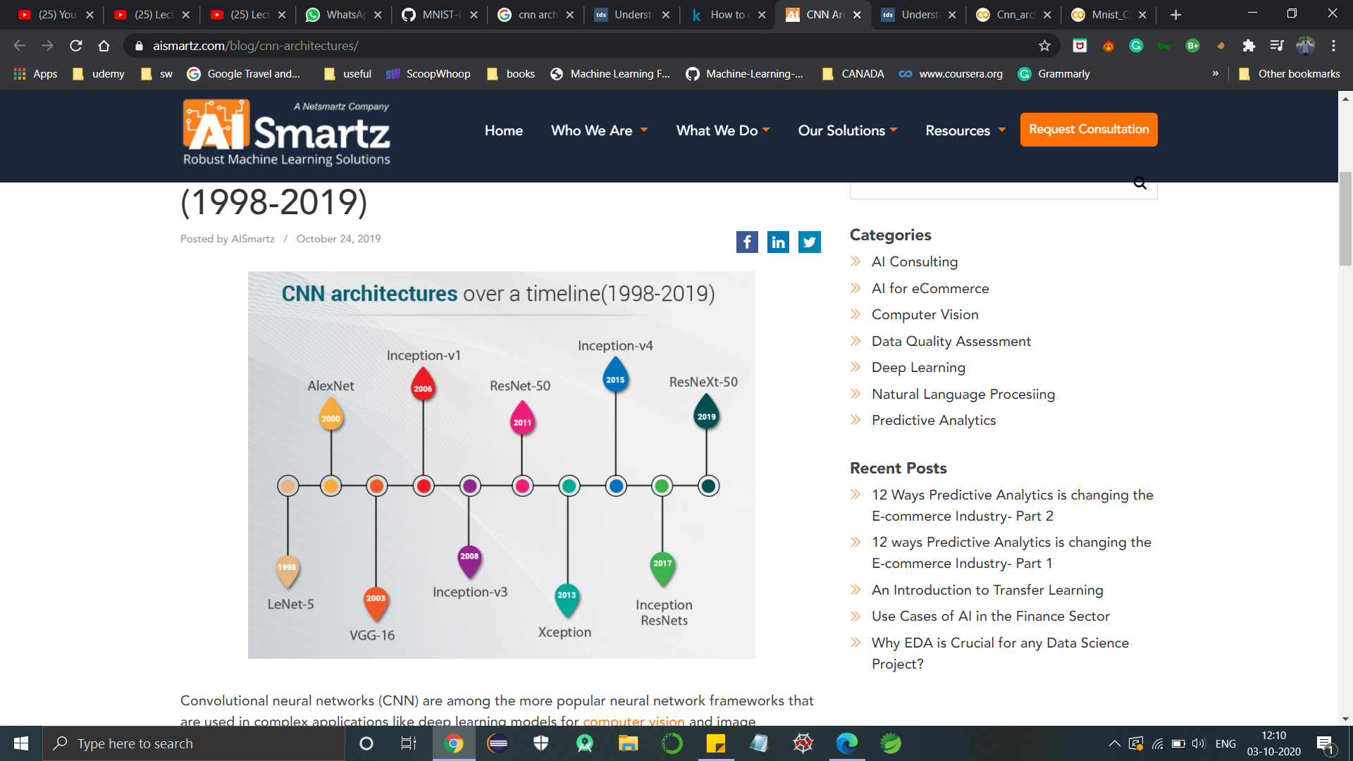

LeNet-5

* It has 2 convolutional and 3 connected layers

Alex Net

* 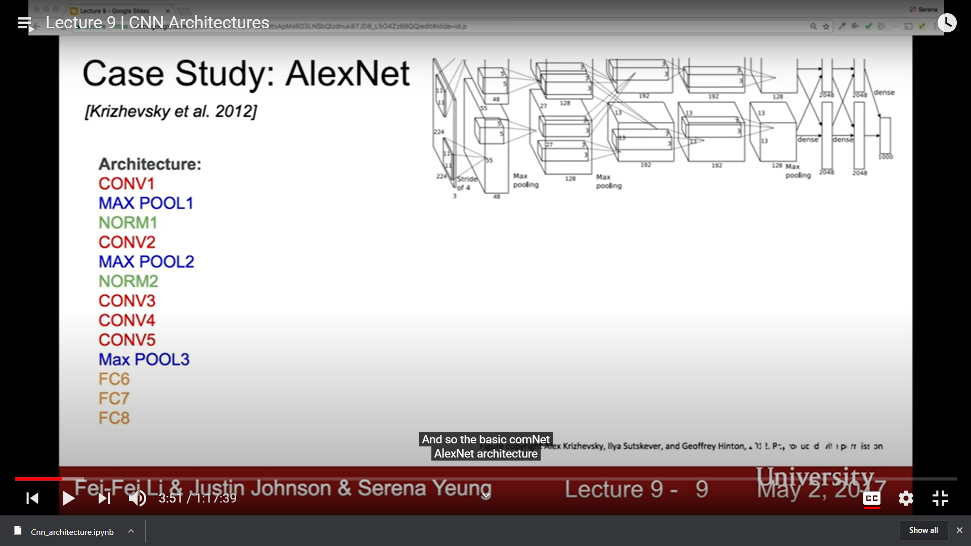
* 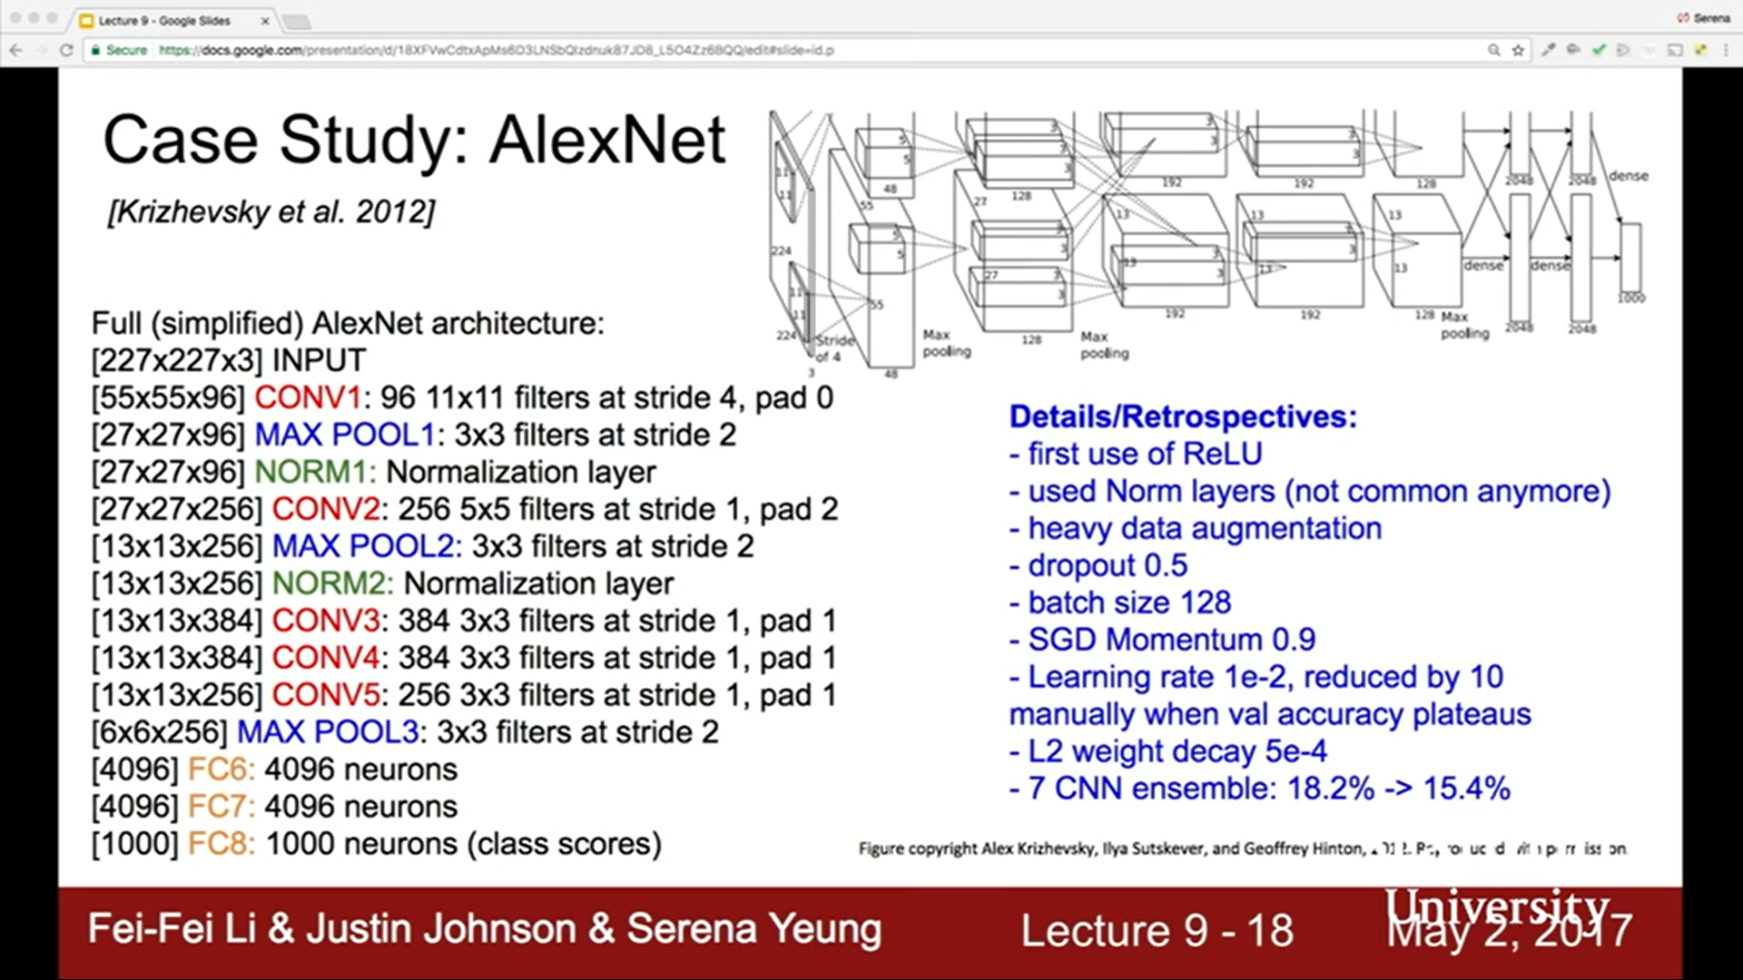

VGG -16

* 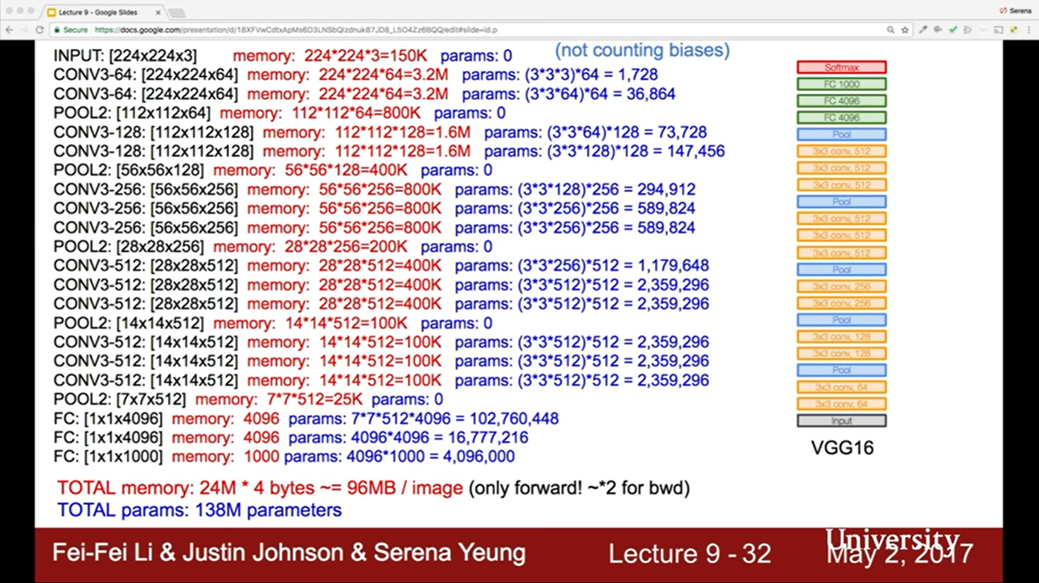

Google net

* 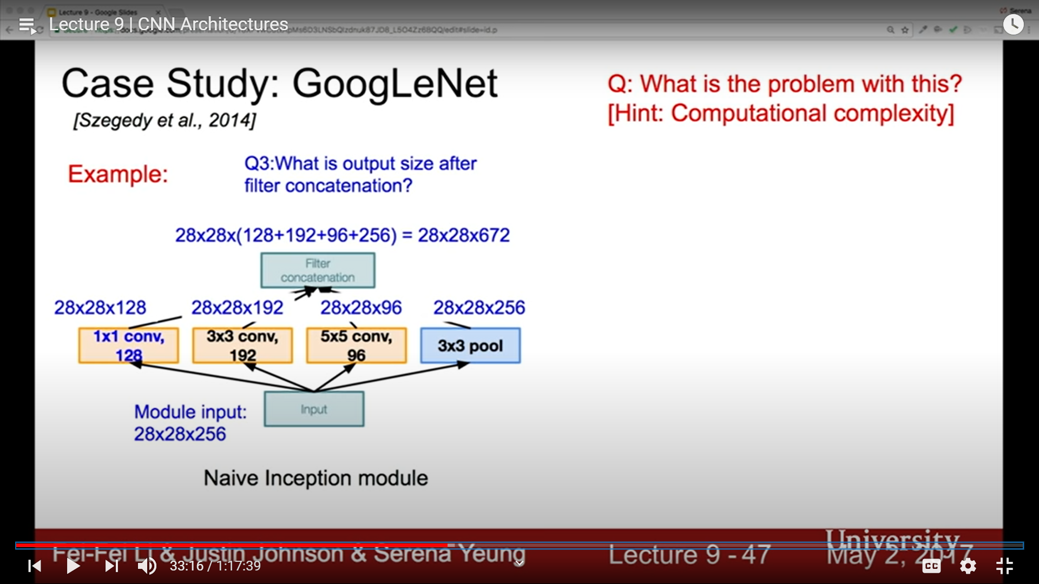
* This is basic inception module
* 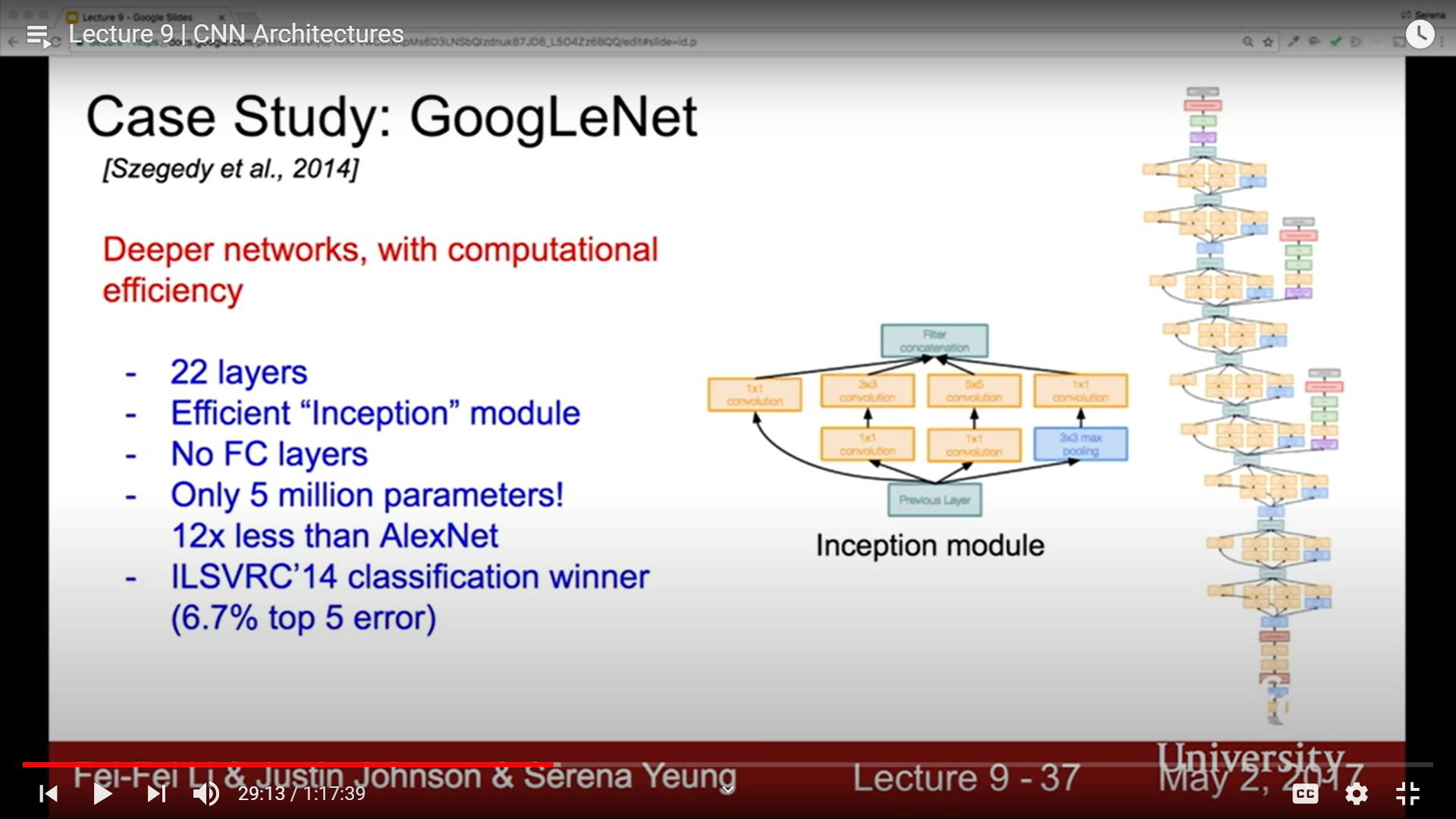
* In this they introduced a inception model, in that input is passed to some convo layer(1,1) and pool layer(3,3) then again passed it convo layer of different strides(1,1),(3,3),(5,5) and this all are aggregated to single and this is input for next inception module
* Reason for going to(1,1) instead (3,3) and (3,5) directly is that , it reduces the depth and works efficiently
* So basically stacking up this inception model they have built this architecture

Whole architecture model of google net

